**Vanilla IMR Manual**

Jin Yang1, Christian Franck1

1Department of Mechanical Engineering, University of Wisconsin-Madison

Email: [jyang526@wisc.edu](mailto:jyang526@wisc.edu)

Last modified date: 2019-04-26

**Contents**

**Section 0.** **Introduction** 2

**Section 1.** **Load *R*-*t*** **curve** 2

**§1.1**  **Get *R*-*t*** **curve by loading IMR images and fitting circles** 2

**§1.2**  **Get *R*-*t*** **curve by executing new numerical simulations** 3

**§1.3**  **Fit *R*-*t* curve using spline interpolation** 6

**Section 2.** **Fit surrounding material properties** 7

**§2.1**  **Vanillia IMR solver with LSQ fitting** 7

**§2.2**  **Vanilla IMR solver with Nelder-Mead fitting** 8

**Section 3.** **Extension: Decoupled IMR solver to fit surrounding material properties** 8

**§3.1**  **Decoupled IMR solver with LSQ fitting** 8

**§3.2** **Decoupled IMR solver with Nelder-Mead fitting** 11

**Acknowledgement** 12

**References** 12

**[Comments]**

In this manual, all lines printed to the MATLAB command window are written in red, parameters that need to be assigned in the MATLAB “main_IMR.m file” are written in black (codes) and green color (comments), and important words and details are highlighted with yellow background color.

## **Introduction**

Vanilla-IMR (Inertial microcavitation rheometry) is a solver for the high strain rate viscoelastic properties of the soft materials surrounding cavitating bubbles written in MATLAB. For full details, please refer to Refs[1, 2].

## **Load *R*-*t*** **curve**

This section loads an *R-t* curve from experimental post-processed data, or numerical simulation data. When you execute this section you will be asked to choose an *R-t* curve type, associated with either extracting bubble radius from an experimental video or executing a new numerical simulation.

---------- Section 1 Load R-t curve ----------

Choose method to load IMR R-t curve:

(1)Load R(t) curve by post-processing IMR experiment images

(2)Load R(t) curve by generating numerical simulations

Input here:

## **§1.1 Get *R*-*t*** **curve by loading IMR images and fitting circles**

If we input “1”, IMR experiment images will be loaded and fit with circles. This procedure requires user input (art-of-work), as it is more robust to fit circles and verify their accuracy frame-by-frame. After fitting circles for bubble boundaries, please skip to **§1.3**.

---------- Section 1 Load R-t curve ----------

Choose method to load IMR R-t curve:

(1)Load R(t) curve by post-processing IMR experiment images

(2)Load R(t) curve by generating numerical simulations

Input here: 1

---------- Section 1.1 Load R-t curve from experiment images ----------

Starting from an IMR video, we detect the bubble radius *R* (*t* ) by fitting circles in all the IMR experimental video frames.

Figure 1. Two typical contrast adjusted bubble frames from IMR experimental video, where bubble radius can be detected by fitting circles. (Left: large bubble and surrounding medium is under compression; Right: bubble is small when it collapses. Image courtesy of H. C. Cramer III.)

**Example 1.1 (Fitting stiff polyacrylamide hydrogel IMR experimental video)**

This example is extracted from Ref [1] IMR experiment, which uses stiff polyacrylamide(PA) hydrogel ($G=7.69±1.12 kPa, μ=0.101±0.023 Pa∙s$). The original experimental video is located at './data/IMR_JE_StiffPA_exp2/PAstiff_xy002.mp4'. Running the code of Section **§**1.1, we fit circles using the video frames to get bubble radius *R-t* curve shown in Figure 2.

%% Section 1.1 Get RofT curve by loading IMR images

% ====== Postprocessing exp images ======

fprintf('-------- Section 1.1 Load R-t curve from experiment images ------ \n');

videoFolderName = ['./data/IMR_JE_StiffPA_exp2/']; cd(videoFolderName);

videoName = 'PAstiff_xy002.mp4'; LoadVideo; % Load video

runCalcRofT; % Need experience and still art of work;

cd('../../'); % Back to main directory

fprintf('---------- Section 1.1 Done ---------- \n\n');



Figure 2. R-t curve obtained from the IMR experimental video for stiff PA hydrogel (IMR video from Ref [1]); c.f. “./data/IMR_JE_StiffPA_exp2” for results video “PAstiff_xy002_RofT.mp4”.

## **§1.2 Get *R*-*t*** **curve** **by executing new numerical simulations**

If we choose to load *R-t* curve by executing new numerical simulations, we need to define corresponding parameters. The viscoelastic properties of the material surrounding the bubble can be modified in the code.

Here, we give one example of executing numerical simulation by assuming material surrounding the bubble follows Neo-Hookean Kelvin-Voigt model, for which $G=2970Pa$ is the elastic modulus and $μ=0.01 Pa∙s$ is the viscous modulus.

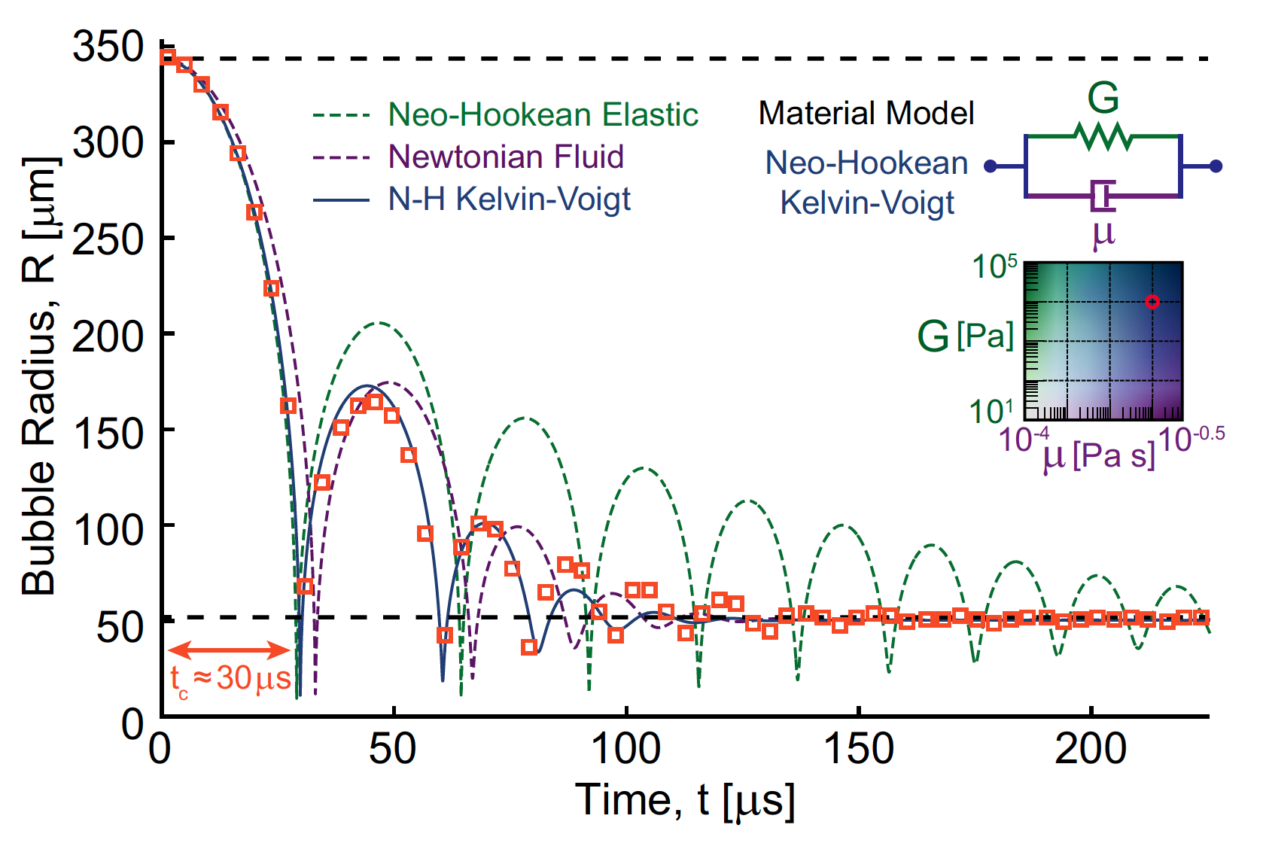

Figure 3. Neo-Hookean Kelvin-Voigt model for cavitation surrounding viscoelastic material.

% ====== Time duration ======

tspan = 2.25e-4;

% ====== Material model ======

G = 2970; mu = 0.01; model = 'neoHook'; simNo = 4;

% ====== Providing initial conditions ======

% (1) Given bubble initial radius and equilibirum radius

ICReqOrPinit = 0; R0 = 225e-6; Req0 = R0*ones(1,1)./[10:-1:6]; expNo = length(Req0);

% (2) Given bubble initial radius and initial inside pressure

%ICReqOrPinit = 1; % R0 = 225e-5; P_guessList = [200]; expNo = length(P_guessList);

All other constitutive models can be initialized in a similar way. (In current Vanilla-IMR, only Neo-Hookean Kelvin–Voigt material model has been fully tested.)

|  |  |  |  |
| --- | --- | --- | --- |
| Index | $$G$$ | $$μ$$ | Notes |
| 1 | 0 | Constant | Linear viscosity fluid |
| 2 | 0 | First order | Nonlinear viscosity fluid |
| 3 | Constant | Constant | Linear Kelvin-Voigt w/ linear viscosity |
| 4 | Constant | Constant | Neo-Hookean Kelvin-Voigt w/ linear viscosity |
| 5 | First order | Constant | Fung Kelvin-Voigt w/ linear viscosity |
| 6 | Constant | First order | Neo-Hookean Kelvin-Voigt w/ nonlinear viscosity |
| 7 | First order | First order | Fung Kelvin-Voigt w/ nonlinear viscosity |
| 8 | Constant | Constant | Nonlinear standard solid w/ linear viscosity |

% ====== Other default settings ======

NT = 500; % Inside bubble spatial grid #;

NTM = 10; % Outside bubble spatial grid #;

IMRsolver_RelTolX = 1e-7; % Matlab ode23tb solver relative tolerance;

TimeRes = 10; % "TimeRes" is the sampling rate you want to set over 270,000/s.

E.g. "TimeRes = 10": we sample R-t data points in the sampling rate of 10*270,000/s.

% All other physical constant parameters, see IMRcall_parameters.m and runIMR_num_simulation.m.

After assigning simulation parameters, runIMR_num_simulation.m will be called automatically, and a wait-bar will visualize the simulation progress. For example, the following *R-t* curve in Figure 5 is generated using the above parameters in gray boxes.

Figure 4. Wait-bar showing numerical simulation progress.



Figure 5. Simulated R-t curve using parameters $G=2970Pa$, $μ=0.01 Pa∙s$.

To imitate an IMR experiment, we set a temporal sampling rate and evaluate discrete bubble radius data *R* from the synthetic *R-t* curve of Figure 5.

 

Figure 6. Red square data are extracted from synthetic R-t curve to imitate IMR experiment with two different sampling rates (Left: 2,700,000 s1; Right: 540,000 s1).

## **§1.3 Fit *R*-*t* curve using spline interpolation**

We fit discrete sampled *R-t* data using piecewise spline interpolation, and then compute first- and second-time derivatives of the *R-t* curve.

Figure 7. Fitted bubble radius R-t curve using sampled data, and its first- and second-time derivatives.

[Comment]

The error of the spline interpolated data in Figure 7 using sampled *R-t* data can be large if the sampling rate of the *R-t* curve is not fast enough.

## **Fit surrounding material properties**

In this section, there are four solver methods can be selected to fit viscoelastic properties of the soft materials surrounding cavitating bubbles. Practically, we don’t need to compute the whole *R*-*t* curve for the fitting process, instead only first several collapse peaks of the *R*-*t* curve are fitted. The number of the collapse peaks of the *R*-*t* curve is stored as variable “PickNo”, which is a positive integer, in the code.

---------- Sections 2-3 Fit material property using vanilla IMR ----------

How many peaks of R-t curve to be used for fitting?

Input here: XXX

Choose IMR solver method:

(1) Section 2.1: IMR solver with LSQ fitting

(2) Section 2.2: IMR solver with Nelder-Mead fitting

(3) Section 3.1: Decoupled IMR solver with LSQ fitting in time segments

(4) Section 3.2: Decoupled IMR solver with Nelder-Mead fitting in time segments

Input here: XXX

## **§2.1 Vanillia IMR solver with LSQ fitting**

In this solver method, first we simulate a collection of *R*-*t* curves using a spectrum values of material properties $\{G$, $μ\}$, and then the $L_{2}$ norm of the differences between all the simulated *R*-*t* curves and the experimental *R-t* curve are computed and stored as in the variable “LSQErr” (Least square fitting error). [Comment: LSQErr variable is also the summation of squared differences (SSD) error over a span of {$G$, $μ$} pairs.] The minimizer of LSQErr is output as the best-fit material properties and stored as “matPropVarList”.

%% Section 2.1 IMR solver with LSQ fitting

fprintf('--- Section 2.1 Fit material property using vanilla IMR LSQ fitting --- \n');

% ====== Define LSQ fitting range ======

G_ooms = 3:0.2:4; % log10(Shear modulus)

mu_ooms = -3:0.25:-1.0; % log10(Viscosity)

alpha_ooms = -Inf; lambda_nu_ooms = -Inf; G1_ooms = inf; % By default other parameters for Neo-Hookean KV material

% ====== Solver ======

runIMR; % Compute LSQ error matrix

% Fitted material property output is in variable: "matPropVarList"

fprintf('---------- Section 2.1 Done ---------- \n\n');

[Comment]

1. This method is slow but robust.
2. Practically, a spectrum values of material properties {$G$, $μ$} values are provided in the log10 form.

## **§2.2 Vanilla IMR solver with Nelder-Mead fitting**

Instead of computing all the *R*-*t* curves over a span of {$G$, $μ$} pairs, we can apply Nelder-Mead method [3] to minimize the objective function “LSQErr” in **§2.1**. This solver method is much faster compared with **§2.1**, but its accuracy depends on the local convexity of the objective function.

   

Figure 8. Illustration of how Nelder-Mead optimization method works (Image modified from wikipedia).

## **Extension:**

## **Decoupled IMR solver to fit surrounding material properties**

## **§3.1 Decoupled IMR solver with LSQ fitting**

There are two improvements in this method compared with **§2.1**.

First, the whole IMR equations (c.f. Refs [1,2]) are decoupled to two sub-systems, where the first sub-system is only related with bubble inside state variables {*p, C, T*}, and it is independent with constitutive models of surrounding materials; while the second sub-system is related with bubble radius *R* and the viscoelastic properties of surrounding materials outside cavitation bubble, which can be used to fit surrounding material constitutive model.

Second, the error in the first sub-system for bubble inside variables {*p, C, T*} can be large when bubble collapses and *R-t* curve is non-differentiable. To further decrease the numerical error, we solve second sub-system within each time segment to avoid bubble collapse moments, see Figure 11.

Execute this section, the following lines will print to the MATLAB command window:

-------- Section 3.1 Fit material property using decoupled IMR w/ LSQ fitting ---------

Do you want to solve first sub-system? 0-No; 1-Yes, accurate; 2-Yes, fast.

Input here: XXX

We can input “1” (accurate solver but slow) or “2” (fast solver but with low accuracy) to solve the first sub-system. The solution of the first sub-system (bubble inside pressure *p*-*t* curve plot) will pump out as shown in Figure 9. Next we need to check the first PickNo collapses pressure in the *p*-*t* curve are in agreement with numbers printed on the MATLAB command window. If these pressure values are consistent with each other, we need to press “Enter” key on the MATLAB command window to start to solve the second sub-system.

====== Expt #: 1 ======

First three collapses where p values are large happens at time:

2.11e-05 3.67e-05 4.78e-05 5.67e-05 6.48e-05 7.26e-05

Double these these time values are correct, and press "Enter".

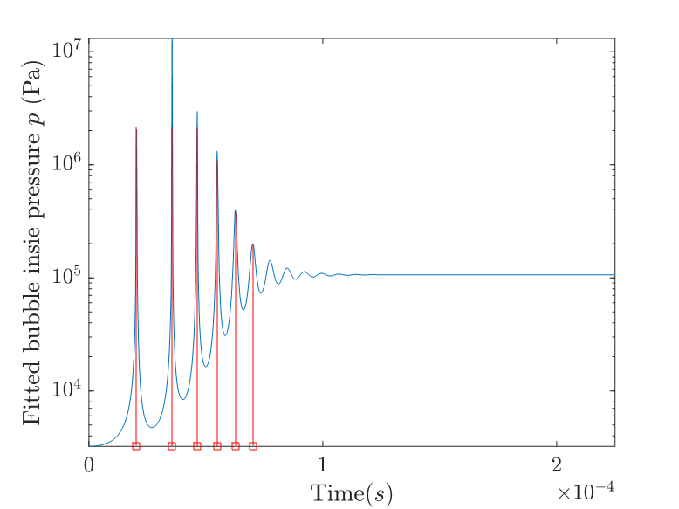

Figure 9. Decoupled IMR first sub-system solved bubble inside pressure p. Please double check first PickNo# collapses’ happening time (marked with □) is the same with values printed on MATLAB Command Window.

Next, we start to manually define time segments to void bubble collapse moments. A plot of *R-t* curve will pump out with a big black cross over the whole figure (see Figure 10 left). Move this big black cross to click data points that are second closest to the vertical dash lines on the *R-t* curve both on the left and right sides (in the *t* increasing order). As shown in Figure 10, both blue and green crosses are data points we should click manually with the big black cross. Press “Enter” when all the blue and green crosses are clicked.

We show one example of solving decoupled IMR system with LSQ fitting (in time segments) surrounding Neo-Hookean Kelvin-Voigt viscoelastic material in Figure 12. In this example, we find that LSQErr objective function has an obvious concave shape near its unique minimizer, and the fitted viscoelastic property of surrounding material has very good accuracy if we have enough *R-t* curve sampling rate.

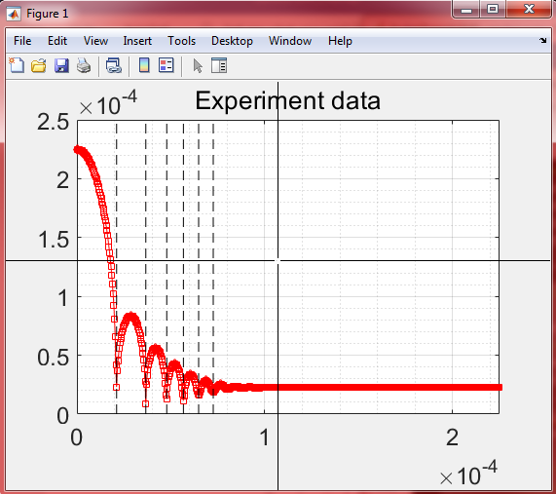 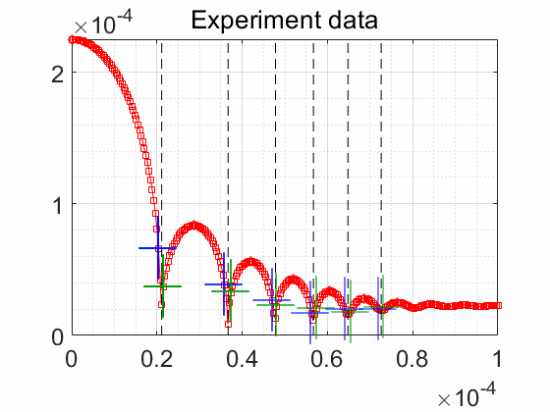

Figure 10. Left: A big black cross will appear to define IMR time segments (Left insert orange box is zoomed in on the right). Right: We need to click both blue and green crosses in the order that t increases to define time segments to avoid bubble collapse moments.

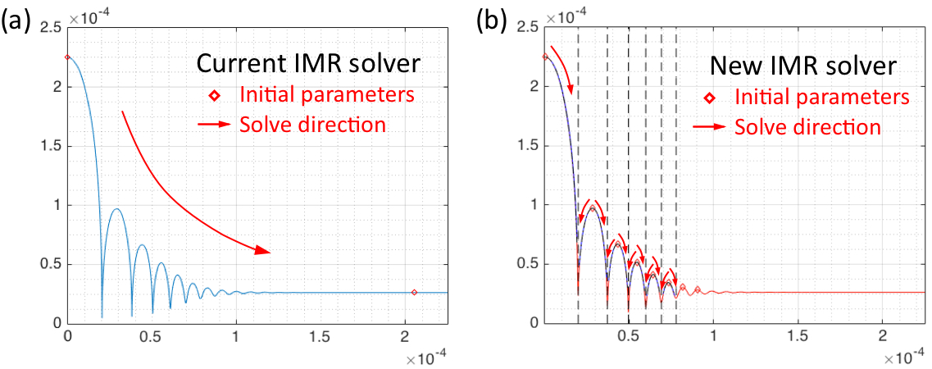

Figure 11. Instead of solving IMR second sub-system over the whole-time span, surrounding material properties are fitted within isolated time segments to avoid collapse moments.

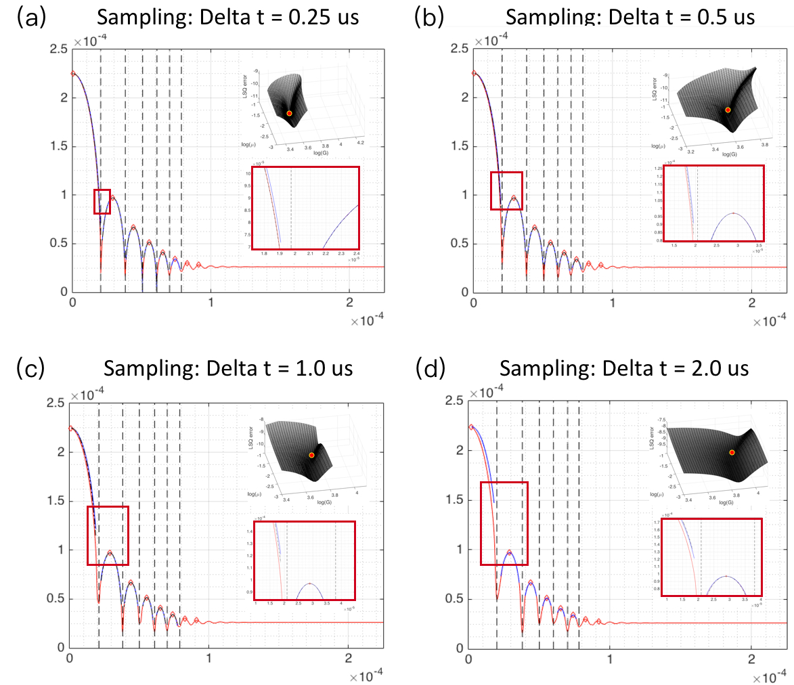

Figure 12. Example of the method “Decoupled IMR solver with LSQ fitting in time segments” fits Neo-Hookean surrounding material viscoelastic property with different sampling rates. Each experiment R-t curve LSQ fitting needs 2-3 hours. Fitted results using sampling rate (a) 4,000,000 s1: Pa, , comparing with exact assigned material modulus in the initial numerical simulation: $G=2,970$ Pa, $μ=0.0100 Pa∙s$.

## **§3.2 Decoupled IMR solver with Nelder-Mead fitting in time segments**

Similar to **§3.1** v.s. **§2.1**, there are two improvements in this method compared with **§2.2**. First, the whole IMR equations are decoupled to two sub-systems, first sub-system is only related with bubble inside variables {*p*, *C*, *T* } and the second sub-system is related with bubble radius *R* and surrounding materials constitutive model. Second, we solve second sub-system within all the time segments to avoid bubble collapses moments and apply Nelder-Mead method.

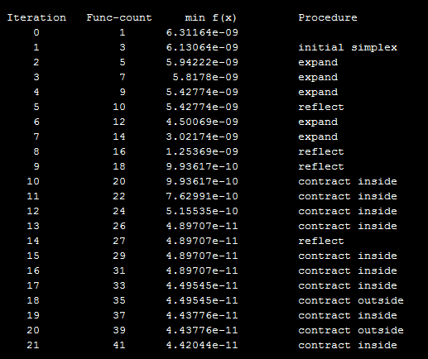 

Figure 13. Example of the method “Decoupled IMR solver with Nelder-Mead fitting in time segments” fits Neo-Hookean surrounding material viscoelastic property. Each experiment R-t curve LSQ fitting needs 2 minutes. Fitted results for sampling rate 2,700,000 s1: Pa, , comparing with exact assigned material modulus in the initial numerical simulation: $G=2,970$ Pa, $μ=0.0100 Pa∙s$.

## **Acknowledgement**

We gratefully acknowledge the funding support from the Office of Naval Research (Dr. Timothy Bentley) under grants N000141612872 and N000141712058. JY acknowledges discussions and help from Prof. Eric Johnsen, Prof. David L Henann, Kazuya Murakami, Anastasia Tzoumaka and Dr. Jonathan B Estrada. Special thanks should be given to Dr. Spencer H. Bryngelson for all the helpful suggestions and improving the writing.

## **References**

1. Estrada, J. B., Barajas, C., Henann, D. L., Johnsen, E., & Franck, C. (2018). High strain-rate soft material characterization via inertial cavitation. *J.Mech.Phys.Solids****.*,** 112, 291-317.
2. Barajas, C., & Johnsen, E. (2017). The effects of heat and mass diffusion on freely oscillating bubbles in a viscoelastic, tissue-like medium. *J.Acou.Soc.Am.*, 141(2), 908-918.
3. Nelder, John A. & R. Mead (1965). A simplex method for function minimization. *Computer Journal*., 7 (4): 308–313.
4. Yang, J., & Franck, C. (2019). Strain hardening effects of soft viscoelastic materials in inertial microcavitation. *Proceedings of the Society for Experimental Mechanics Series.* Accepted.